Tech. Specs. Sheet | Rolling Sutter | 
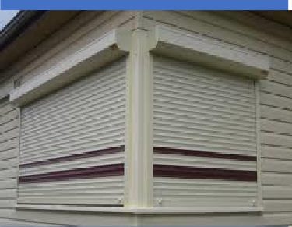

Motorized Rolling Sutter
Door type | Motorized Rolling Sutter
Clear Opening dimension (w) -- x (h) -- | - (W)6045 x (H)5994 mm – 1 Qty
 | - (W)6077 x (H)5994 mm – 1 Qty
 | - (W)6782 x (H)6706 mm – 1 Qty
Opening Direction | Vertical - from bottom to Top
Mounting Location area | Inside area
Mounting Surface | Side Brackets: Steel  Guides : Steel
Opening/Closing Speed | 0.5 m/sec
Door Material
material | GI
Panel | The panel made of 1mm thick GI
Profile | Corrugation
Bottom Profile | M. S. Plate 100 mm x 2.5 mm thick with angle stiffener with Rubber Bottom Seal
Side Guide Profile | MS Guide 100 X 3 mm thick
Roller Shaft | M.S. Tubular Pipe with Flange & machined shaft at the ends Pipe Dia -100 to 300 mm as per w x h will vary
Side Brackets | MS Plate 5 mm thick , as per the opening dimension
Hood Cover | Made of GI Sheet Thickness 0.9 mm

Tech. Specs. Sheet | Rolling Sutter

Surface finish
Painting | Two coats of epoxy primer & one coat of synthetic enamel paint.
Automation
Control Type | Pulse Control with push button
Drive Unit & Mounting Type | Electric Motor (Imported) (single phase / three phase) - Indirect Mounting - Sprocket chain arrangement
Emergency Operation | Manual Chain
Operating Switch | Push Button from inside
Installation check points | Need to be check = space requirements + substructure + Mounting access + Access in the event of power cut

Structure too mount Rolling Shutter client scope

